Williamson County Amateur Radio Emergency Service (WCARES) Search and Rescue (SAR) Team Standard Operating Procedures (SOP)

Revised February 19, 2016

1. Introduction
The Williamson County Amateur Radio Emergency Service (WCARES) Search and Rescue (SAR) Team consists of trained volunteers dedicated to supporting the SAR needs of Williamson and surrounding counties. Like the ARES from which it was born, WCARES SAR exists to support the Williamson County (Tennessee) Emergency Management Agency (WCEMA). The main objective of WCARES SAR is to provide trained and equipped volunteers to aid WCEMA in the search and recovery of missing persons in Middle Tennessee.
While WCARES SAR is a special interest group under the umbrella of the larger WCARES organization, the team reports directly to the Williamson County Emergency Management Agency for deployment and training issues.

1.a. Facts and Assumptions
The WCARES SAR Team’s primary area of service is Williamson County, but the WCEMA may request its service in adjacent counties or states in response to a mutual aid request.
Team members are on call 24 hours a day, 7 days a week. However, it is understood that not every member will be able to respond to every call out do to fulltime employment, family, and personal, considerations. For that reason, it is necessary to maintain a large pool of trained and exercised team members at all times.
Team members are aware that SAR activities are potentially hazardous and there is the possibility of serious injury and/or loss of personal property. In order to maintain membership, team members sign a statement acknowledging this risk and the fact that those risks are borne by the individual and not the team, its officers, or the government of Williamson County, TN (see Appendix 3).
Team members are required to carry adequate personal health and auto insurance and individuals participating in SAR Team activities assume all responsibilities and consequences related to their participation.
Team members will thoroughly understand and abide by the guidelines contained in this SOP.
Team members will maintain a level of personal fitness and readiness sufficient to endure the rigors of SAR field operations.

2. Individual Training and Qualifications

2.a. Basic Membership Requirements
In order to be considered for membership in the WCARES SAR Team, individuals must:
- Be at least 18 years of age.
- Have a valid driver’s license.
- Be able to work under stressful conditions.
- Be able to work outside in all kinds of weather, during all seasons, and at any time day or night.
- Be responsible for the purchase and maintenance of their own personal equipment, as outlined in this SOP.
- Be available for Team training and activations.
- Submit to a criminal history check (annual requirement).
- Agree in writing to hold harmless WCEMA and Williamson County (including any and all persons working on their behalf) from any liability related to any injuries and or other conditions incurred as a result of participating in Team training, events, or mobilizations by signing and submitting a Liability Release Form found in Appendix 3.
- Maintain cell phone service and the ability to text message.
- Possess a current FCC Amateur Radio License (Technician or higher) or agree to obtain licensure within twelve months of joining.

Acceptance of these requirements by a candidate allows the team to extend Provisional membership to the candidate. Provisional membership makes the individual eligible to attend county sponsored TEMA courses (Search Operations, GPS Land Navigation, and Basic Visual Tracking), attend monthly training meetings, and participate in quarterly training exercises. Provisional members are not eligible to participate in real world mobilizations. The primary focus of a Provisional member is to complete the training requirements necessary for promotion to the position of SAR Technician or Support Technician as quickly as possible but in no more than one year’s time. If a Provisional Member does not attain SAR Technician or Support Technician in one year or less, they will be discharged from the team.

2.b. Non-Provisional Membership Levels
Provisional members reach “full” membership status when they complete the requirements of one of three membership classifications: SAR Technician, Support Technician, or Crew Leader.

SAR Technician
SAR Technicians are the operational base of the team. They conduct searches in wilderness environments under the direction of a Crew Leader, Assistant Team Captain, or Team Captain. Provisional members reach the level of SAR Technician when they:
- Complete TEMA Search Operations.
- Complete TEMA GPS Land Navigation.
- Possess a FCC Amateur Radio License.
- Complete American Heart Association Heartsaver First Aid.
- Complete a physical fitness test consisting of a three mile walk on level or moderately rolling terrain with a 25 pound backpack in 90 minutes or less.
- Complete FEMA IS-100, 200, 700, and 800.
- Participate in one quarterly field exercise and receive a proficiency endorsement from the Team Captain, Assistant Captain, or Training Officer.

Support Technician
Support Technicians support the team from the Incident Command Post. They run the Team net, maintain select ICS forms for the Team, serve as a communications conduit between the Incident Commander and team members in the field, and track field members in route to the staging area and on mission in the field using APRS and voice reports. Provisional members reach the level of Support Technician when they:
- Complete TEMA Search Operations or NASAR SAR Tech III.
- Complete TEMA GPS Land Navigation or demonstrate proficiency in plotting and reading map coordinates. Proficiency will be judged by the Team Captain, Assistant Captain, or Training Officer.
- Possess a FCC Amateur Radio License.
- Demonstrate proficiency in Net Control Procedures by running one WCARES net or WCARES SAR net during a quarterly exercise.
- Complete FEMA IS-100, 200, 700, and 800.
- Complete FEMA ICS-300.
- Demonstrate proficiency in downloading GPS tracks from Garmin GPSMap 64 series devices, constructing routes and waypoints in Garmin Basecamp, and transfer that data back to devices.
- Demonstrate proficiency in using APRS to track searchers in the field.
- Understand and be able to explain APRS network design tenants.
- Understand how and when to employ APRS Digipeaters and IGates to extend APRS coverage based on terrain or distance.

Crew Leaders
Crew Leaders serve as supervisors to SAR Technicians in the field in order to provide experienced mentorship and effectively extend the span of control of the Team Captain or Incident Commander. In the training environment, Crew Leaders will mentor up to seven SAR Technicians habitually in order to improve Team mobilization times, improve the consistency of Team member assessments, and assist the Team Captain. Crew leaders must complete all the requirements of SAR Technicians as well as:
- Participate in two quarterly Team exercises as a SAR Technician or two real world mobilizations as a SAR Technician.
- Complete TEMA Managing Search Operations.
- Complete TEMA Basic Visual Tracking.
- Complete ICS-300.

Crew Leader responsibilities include but may not be limited to:
1. Thoroughly understand and abide by the guidelines contained in this SOP.
2. Provide overall Crew leadership and enforce SAR Team Standards.
3. Encourage assigned Crew members to participate during training opportunities on a regular basis.
4. Ensure assigned Crew members maintain required equipment at all times in accordance with SAR Team Minimal Personal Uniform and Equipment Standards.
5. Encourage assigned Crew members maintain a level of fitness in order to be able to endure the rigors of SAR field operations.
6. Encourage assigned Crew members to respond to Team activations when available and conduct SAR operations as directed.
7. Provide leadership and look to the health, welfare, and safety of assigned Crew members during SAR field operations.
8. Provide support to the Team Captain as required.

Figure 1 – Membership Levels

2.c. Universal Team Member Responsibilities
SAR Team members’ responsibilities, regardless of membership level (Provisional, SAR Technician, Support Technician, or Crew Leader) include but may not be limited to:
1. Thoroughly understand and abide by the guidelines contained in this SOP.
2. Participate during training opportunities on a regular basis to remain proficient in the skills needed to participate in SAR field operations. Team members must attend 2/3 of annual training meetings and exercises per calendar year at a minimum.
3. Maintain personal records of required training.
4. Maintain required equipment in accordance with SAR Team Minimal Personal Uniform and Equipment Standards (see 8.a. and Appendix 2).
5. Maintain a level of fitness in order to be able to endure the rigors of SAR field operations.
6. Respond to Team activations when available and conduct SAR operations as directed.
7. Carry adequate personal health and auto insurance.
8. Maintain up-to-date contact information with the Team Secretary to include a current address, cell phone number, home telephone number, work telephone number, and e-mail address.
9. Team members report to their assigned or designated Crew Leader.
10. Team members that miss four or more consecutive training meetings may be removed from the team roster at the direction of the WCARES SAR Team Captain.

3. Organization
In order to facilitate Team operation in both the mobilized and training environment, non-provisional team members (i.e., SAR Techs, Support Techs, and Crew Leaders) may additionally serve in organizational administrative roles. Individuals holding these positions may additionally be referred to as Team Officers in this document.

Figure 2 – Organizational Chart

3.a. Command Team
The SAR Team Captain and Assistant Team Captain are selected annually by vote of the membership. The SAR Team Captain is the Team’s senior leader. The Team Captain’s responsibilities include but may not be limited to:
1. Thoroughly understand and abide by the guidelines contained in this SOP.
2. Provide overall Team leadership and enforce Team Standards.
3. Designate, develop, and support Crew Leaders and Staff development as needed.
4. Designate other Team support positions as needed.
5. Coordinate the SAR Team training calendar with the Team Training Officer and WCEMA Training Officer.
6. Coordinate and lead monthly SAR training events.
7. Encourage Team members’ participation during training opportunities on a regular basis.

3.b. Administrative Staff Positions
The following staff positions exist to support the operation of the Team. All of the following roles exist as additional duties. In other words, members are SAR Techs, Support Techs, or Crew Leaders first and they may additionally perform the duties of the following appointments. When performing the duties of an Administrative Staff Position, Team members advise the Team Captain directly. However, when not actively performing the duties of these roles, those individuals report to their Crew Leader. All positions are assigned by annual vote of the membership.

Quartermaster
1. The Quartermaster maintains and services designated Team equipment between training events and mobilizations.
In a large response, the Team Quartermaster may be asked to serve on the IC’s General Staff under the Logistics Section Chief.

Secretary
1. Ensure Team member attendance and participation time (volunteer hours) is recorded.
2. Ensure Team members provide up-to-date contact information including: a current address, cell phone number, home telephone number, work telephone number, and e-mail address.
3. Record training delivered during monthly meetings for those members not able to attend in person.

Training Officer
1. Develop and publish the training calendar for the calendar year in November in consultation with the Team Captain and his/her assessment of team strengths and weaknesses.
2. Coordinate instructors for monthly training meetings.
3. Design and execute quarterly field training exercises.
In a large response, the Team Treasurer may be asked to serve on the IC’s General Staff under the Operations or Planning Section.

Safety Officer
While it is the duty of all Team members to identify and mitigate hazards to themselves and to the team, the Safety Officer has a doctrinal responsibility to formalize this process and apply concerted thought to the risks posed by a particular mission or exercise. Once identified, the Safety Officer applies controls to mitigate the risk level down to a level the Incident Commander or Team Captain deems acceptable in light of operational requirements and constraints. The Safety Officer briefs the hazards and controls prior to the dispatch of personnel from the Incident Command Post and enforces the implementation of those controls throughout the mobilization. Finally, the Safety Officer continually reviews conditions for changes in the hazards or an increasing risk level and advises the Team Captain on steps needed to mitigate the increase.
The Safety Officer works closely with the IC and Operations Section Chief to ensure the safety of all incident personnel. The Safety Officer can exercise authority to halt any unsafe operation. There will only be one Safety Officer for each operational period per incident.

Public Information Officer
The PIO maintains the Team's website and endeavors to secure media coverage for Team exercises in order to improve recruiting and maintain the perceived professionalism of the Team.

Treasurer
The Treasurer explores steps needed to establish the team as a tax exempt non-profit. If, at some point, the team decides to levy dues in order to make team gear purchases, the Treasurer will collect, track, and disperse these funds. The Assistant Team Captain will review applicable bank statements and cancelled checks at the Training meetings as an independent check on the handling of funds.
In a large response, the Team Treasurer may be asked to serve on the IC’s General Staff under the Finance/Admin Section Chief.

3.c. Sub Committees
Sub committees exist within the organization to examine complex issues, determine recommendations on the best way for the team to proceed in light of those problems, and present recommendations for adoption during monthly training meetings. New subcommittees may be created at any time at the direction of the Team Captain. Members of subcommittees may be appointed or volunteer. Subcommittees may also be dissolved by the Team Captain when their services are no longer required. The following subcommittees exist at this time:

Gear Adoption
Charged with reviewing current technology and gear and presenting members with well-reasoned and objective selections for personal acquisition. To streamline training, troubleshooting, and interoperability, it is in the best interest of the team to coalesce around specific models of equipment. This equipment will be deemed critical gear. For example, GPS units are deemed critical gear in this team. The recommendations of the Gear Adoption Sub Committee when it comes to critical gear should be considered a strong recommendation. It is not required that members observe the sub committee’s recommendations in this category, but they are strongly advised to. The inability of the owner to interface with other users due to incompatible equipment will be borne by the individual. For example, if an individual adopts a GPS other than that recommended by the sub committee and it does not work with the data cable that the Support Technicians maintain, it is on the individual to find a way to get those tracks to the Support Technician in a way that they can download it.
Other recommendations made by the Gear Adoption Sub Committee focused on items that don’t drive interface issues are provided as a service to the members. These non-critical recommendations may include things such as backpacks or flashlights, for example.
The current GPS recommendation of the Gear Adoption Committee is the Garmin GPSMap 64st. Members who do not use a 64 series Garmin are responsible for supporting their own gear with 24k topo maps, providing the Support team with *.gpx tracks, and programming waypoints and routes provided by the Support team. Devices used in lieu of the recommended GPS must be waterproof, compatible with Garmin Basecamp, and be campable of operation on AA batteries.

Radio Adoption
It is extremely important that team members coalesce around one Handheld Transceiver (HT) in order to allow for easy emergency field reprogramming, troubleshooting, training, and accessory compatibility (spare batteries, hand mics, antenna connectors, etc). The recommendation of the Radio Adoption Sub Committee for HT selection will be considered a critical recommendation. However, due to the cost of HTs, particularly those with true dual VFO capabilities and integrated APRS, it is understood that it may be a 1-2 years before members will be able to shift to a single team standard.
HT recommendations should be determined based on battery life, cost, durability, and APRS integration. It is worth noting that selection of one radio for team comms does not preclude members from retaining other HTs as a backup or as a means of monitoring Public Safety frequencies if the recommended radio is not capable of wideband reception.
Beyond the selection of a team HT, the Radio Adoption Sub Committee may also experiment with and formulate recommendations on how to build durable field antennas for the improvement of HT reception and range.
The current radio recommendation of the Radio Adoption Committee is the Yaesu FT2DR. At a minimum, members must possess a Handheld Transceiver for Team communicaitons. APRS and System Fusion Group Monitor (GM) functionality is recommended to increase safety, situational awareness, and team utility.

Standard Operating Procedure (SOP) Development
The SOP Development Sub Committee is responsible for formulating this document and periodically reviewing it for recommended changes based on emerging best practices and the experiences of the team.

4. Call Out Procedures
In anticipation for a no notice mobilization, all team members will maintain a call out bag that remains packed at all times, minus perishable items. This call out bag will contain all gear that the team member needs in order to sustain operations for up to 24 hours without resupply. If a call out bag is incomplete, it should be tagged. The tag should list all last minute items that need to be grabbed before the team member departs.
All notifications for activation will come via phone tree.
Activation requests will include the following at a minimum:
a. Name of organization initiating emergency request.
b. Nature of dispatch (number of people needed).
c. When and where is the team wanted at the staging area.
d. When, where, and to whom should the team leader report to on arrival.
e. Staging area location.
f. Any special details or circumstances.
g. Call off procedures.
Members will maintain a Tennessee Road Atlas as a backup for movement to the Staging Area. To state this again, members will backup their GPS by having paper maps of the state in the vehicle at all times.
Under no circumstances will team members “self deploy” to an incident. We go because the Team was requested or not at all. Unrequested assets that appear at an Incident Command Post unnecessarily distract ICs and drain resources. They are a hindrance rather than a help. If the Incident Commander needs additional resources, he/she will request them formally through the WCEMA.
Team members are not authorized to use emergency lights or audible warning devices of any kind (to include horns) while en route to a SAR Incident. Violation of this rule will lead to team dismissal and possible criminal charges. Obey all posted speed limits and proceed to the Staging Area in a safe manner.
Team members who are under the influence of prescription drugs that effect the ability to drive or alcohol at the time of a call out will excuse themselves from the mobilization.

4.a. Arrival on Scene
The Team Captain or Assistant Team Captain will report in to the IC upon arrival at the staging area. If the Team Captain or Assistant Team Captain is delayed, the first Crew Leader on scene will report in to the Incident Commander. Only Crew Leaders or higher will approach the IC. During this report, the senior representative will report the number of personnel in the Staging Area, the number en route, and the ETA on the last projected arrival. For larger events the IC will designate an Operations Section and a Staging Area Manager (SAM). If a SAM exists, report in to him or her.
It is extremely important that people who arrive at the Staging Area be seen as professionals. The Team’s reputation and future employability depends on it. Appearance is important and how team members speak to each other and partner agencies is critical.
Team members will sign in using ICS 201.
The senior member on scene will establish and maintain an Incident Log (ICS 214). This log will be passed on to NCS upon their arrival.
The Team will not begin searching until the IC has obtained a completed Missing Person Questionnaire. The information from this questionnaire should be shared with the Team in order drive the search area and increase the effectiveness of team members.
The COML will brief the Communications Plan.
The Safety Officer will brief identified hazards and controls as well as lost searcher procedures.
Team Leadership, Crew Leaders and Team Members will not publically contradict the IC or the supported agency’s staff. If team leadership believe that an error is being made, they can tactfully address the issue with the individuals involved in private. If the decision stands, the senior team member must make a decision. If the action presents a safety issue or puts searchers at too great a level of risk, the team will tactfully request to be demobilized. If the issue is simply a matter of difference of opinion over technique, the team will follow the direction of the IC to their fullest measure.

5. Field Operations
Once team members arrive at the Incident Command Post, they will be logged in by the NCS and paired with another team member for the duration. From that point on until released from the scene, no team members will travel alone.
In recognition of span of control, Crew Leaders will be assigned 3-7 personnel. Every attempt will be made to honor habitual SAR Tech / Crew Leader pairings from the training environment. Depending on response rates, this may not be possible.
All team members must sign out with NCS once released.

6. Demobilization
Before team members are demobilized, they will conduct a “hot wash” to talk about lessons learned. They will additionally sign out before leaving the scene. The senior team leader will ensure that team comments are relayed to the IC for the supported agency’s final After Action Review.

6.a. Critical Incident Stress Debriefing
After any SAR Incident in which the Team comes into contact with a deceased or injured victims, members will be afforded the opportunity to participate in a Critical Incident Stress Debriefing (CISD). Team members are strongly encouraged to participate in the CISD but participation is not mandatory.

7. Training
WCARES SAR Team training standards are based on the courses offered by TEMA and only those courses are required for WCARES SAR Team membership. However, members are encouraged to additionally seek out National Association for Search and Rescue classes in order to improve skills and stay abreast with nationwide best practices and to improve compatibility with other teams. It is worth noting that the Tennessee Association of Rescue Squads formally adopted NASAR standards in 2015.

8. Miscellaneous Provisions

8.a. Uniforms
Members are required to purchase and maintain uniforms in order uphold the professional appearance of the team in the eyes of the public and Public Safety partners. The standard uniform consists of hiking boots with ankle support, wool or synthetic socks (no cotton), khaki 5.11 style pants (no baggy combat style fatigues), and the team polo or long sleeve shirt (based on weather and operational hazards).
The team short sleeve shirt is the… TBD.
The team long sleeve shirt is … TBD.
At this time, there is no standard jacket in order to keep personal outlays under control.
If desired, hats may be worn. However, they should be a khaki baseball style hat with no lettering or pictures. Again, this is to project a professional appearance so that the Team will be called on more readily by served agencies in the future.

8.b. Photography
Members are authorized to take pictures during exercises and training for personal use provided those being photographed raise no objection from those being photographed. Exercising caution, members may take photographs during SAR incidents. However, at no time will photographs be taken of those being aided out of respect for their privacy.
Team members will not post information on social media regarding a SAR incident without prior approval from the Incident Commander or Public Information Officer.

8.c. Personal Liability and Responsibility
The WCARES SAR Team does NOT provide any kind of insurance coverage. All members must realize that the activities of WCARES SAR Team are hazardous and that there is the possibility of death, disability, and/or loss of property and that the individual recognizes and accepts these risks, releasing WCARES SAR Team, its members, and its officers from all liability. Members are expected to carry adequate personal health, life, disability, and auto insurance on their own.
Members of WCARES SAR Team should not expect the organization to provide official assistance to members involved in case of accident, illness, auto accident, or lawsuits arising out of his/her membership with the organization. Again, individual participants in WCARES SAR Team functions assume all responsibilities and consequences of all actions/events.
Members are expected to behave responsibly and professionally at all times. Adequate dedication to WCARES SAR Team activities, including meetings, training sessions, and official mobilizations is required. It is understood and accepted by all that members may not be able to attend all Team functions, but an obvious laxity in dedication is not acceptable and constitutes grounds for dismissal.
Members are also individually responsible for understanding and complying with all federal, state, and local laws or regulations that may apply to the individual, the organization, or its activities.

8.d. Discipline
While on a SAR incident scene, any Crew Leader can dismiss someone from the field at any time without discussion and that person must be prepared to leave as ordered. This is only done when necessary to protect the group and maintain the safety of its members. It is a condition of membership that members understand and accept this situation.
Dismissal of a member from the program can occur if a member demonstrates a pattern of misconduct, disrespect for teammates, a lack of professionalism towards Public Safety partners, or a failure to attend at least 8 out of 12 training events annually. The Team Captain has the authority to make decisions regarding program dismissal. Members may appeal the decisions of the Team Captain to the WCARES Emergency Coordinator and the WCARES Planning Committee.

8.e. Radio Communications
Keep radio communications short, concise, and professional.
Refrain from using subject names on the air.
Expect the search subject’s family or friends to be in earshot of radios at the ICP at all times. For that reason, never indicate over the command net that the subject has been found deceased or critically injured. FCC regulations require that Amateur Radio operators not use codewords or otherwise obfuscate the true meaning of messages while on Amateur frequencies. For that reason, searchers with information that might be troubling to family or friends on the subject will request that NCS change to the alternate frequency designated for Amateur use in the Communications Plan. NCS will acknowledge, announce to all stations that it is changing frequencies temporarily, and switch to the alternate frequency. After NCS confirms that no unidentified individual is within earshot of their radio, NCS will request that the initiating station send their traffic. If the subject is deceased, the initiating station will simply state, “The subject has been found.” Transmission of this message is accurate and is not an obfuscation of the truth. None the less, all team members will recognize that the transmission of this message after a request to shift to the alternate frequency carries additional unspoken meaning. After the message is received, the NCS will inform the initiating station that it is returning to primary, both stations will return to primary, and NCS will announce to the net that it is back on primary. If an additional Amateur with a radio is with the NCS or the NCS has two radios, the additional Amateur or second radio can be shifted to the alternate frequency while the primary radio remains on frequency.

8.e. Lost Team Member
If a team member becomes separated from the Team, the Team will shift focus to finding the team member before returning to the original search.
If a team member realizes that they no longer have line of site on the rest of the team, they will take the following steps in order.
1. Stop moving.
2. Attempt to reestablish contact by calling out.
3. Give a loud whistle blast and wait for a response. Repeat three times.
4. Contact net control, give them your coordinates, and inform them that you have become separated from your team. NCS will relay your coordinates, if necessary, and route team members to you.
5. If you cannot reach NCS, call for “Any Station This Net.”
6. If 2-5 yield no contact, set a stopwatch for 60 minutes. Every five minutes, retry contact initiation via voice, whistle blast, and radio. Hydrate and eat. If no contact is made within 60 minutes, mark your last known point with a six foot streamer of marking tape, write your name, the current time, and the panic azimuth on the marking tape and begin movement in accordance with the panic azimuth. Follow the procedures outlined in the lost searcher portion of the safety brief to ensure a safe return to the ICP. Attempt to reestablish contact throughout the return trip.

8.f. Whistles
All team members are required to carry a high decibel beadless whistle at all times.
1 blast = I need assistance, move to my location.
2 blasts = I hear your request for assistance, continue signaling to help me locate you.
3 blasts = Return to ICP.

Appendices

Appendix 1: WCEMA SAR TEAM CODE OF CONDUCT
Every WCARES Search and Rescue Team Member represents the SAR program to new members, to the public, and to those to whom we render our services. It is important to portray a positive image. As a WCARES SAR Program Volunteer, you are expected to comply with the following:
1. Do not self-deploy to searches; only WCEMA officials can activate the team.
2. Stay within the scope of your training. You have been trained in accordance with Tennessee Emergency Management Agency best practices. Confine your actions to those guidelines and stay within the scope of your training and certification.
3. Always report to training exercises and real world mobilizations in the designated uniform and with the required minimum equipment listed in Appendix 2 of the SAR SOP.
4. Confine your actions to your physical and resource limitations when responding as a member of SAR. Such limitations may be determined by, but not limited to, equipment available, physical abilities, knowledge, authority and hazards.
5. Conduct yourself with professionalism, dignity and pride, and act appropriately and responsibly at all times while assisting others.
6. Treat fellow team members, visitors, other volunteer program participants, guests, and property with respect and courtesy.
7. Be sensitive to the diversity of team members and those we assist.
8. Direct anyone who is looking for official statements from the served agency to the on-scene Public Information Officer.
9. Respect the privacy of persons served by the SAR Team and hold in confidence all sensitive, private, and personal information.
10. Keep SAR leadership informed of any progress, concerns, or problems with tasks which you have been assigned.
11. Do not report for duty while under the influence of alcohol or drugs.
12. While conducting the business of the WCARES SAR Team, you are forbidden to carry firearms on your person.
13. You shall not authorize the use of, or use for the benefit or advantage of any person, the name, emblem, endorsement, services or property of the WCARES SAR program without the approval of the Team Captain.
14. You shall not accept, or seek on behalf of any other person, any money or gifts as a result of your affiliation with the WCARES SAR program.
15. You shall not use your participation in SAR to promote partisan politics, religious matters, or positions on any social or political issue.
16. You shall avoid inappropriate conduct, both on- and off-duty, that would jeopardize program effectiveness. Such behavior includes, but is not limited to:
a. Offensive or profane language or gestures
b. Public criticism of a SAR team member, its leaders or the program
c. Jeopardizing another team member's safety
WCARES SAR is committed to a policy of fair representation and will not discriminate on the basis of race, ethnicity, age, disability, gender, color, religion, sexual orientation, geography, or group affiliations. Volunteers will adhere to these same standards in the course of their duties.
Violations of this Code will be thoroughly investigated. During the investigation involved members will be temporarily suspended from SAR activities, pending the outcome of the investigation. Members will be notified as to their status with the SAR program by the Team Captain.

______________________________________________________________________
Print Sign Date

Appendix 2: Required Equipment List
At this time, the Team is adopting the NASAR SAR TECH II packing list (as of October 2004) as a minimum standard. Team members will report to callouts with this gear and can customize what leaves the staging area based on the situation and the direction of the Team Captain.
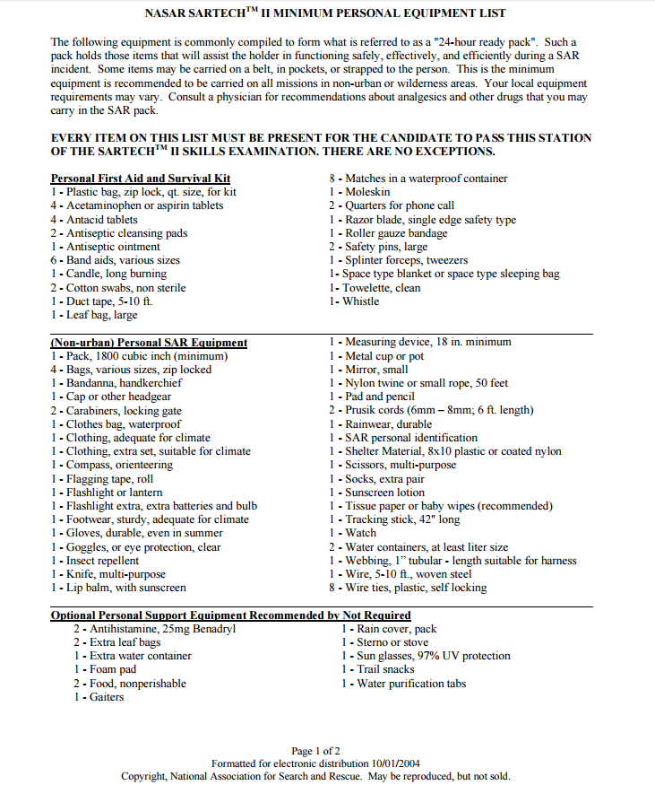
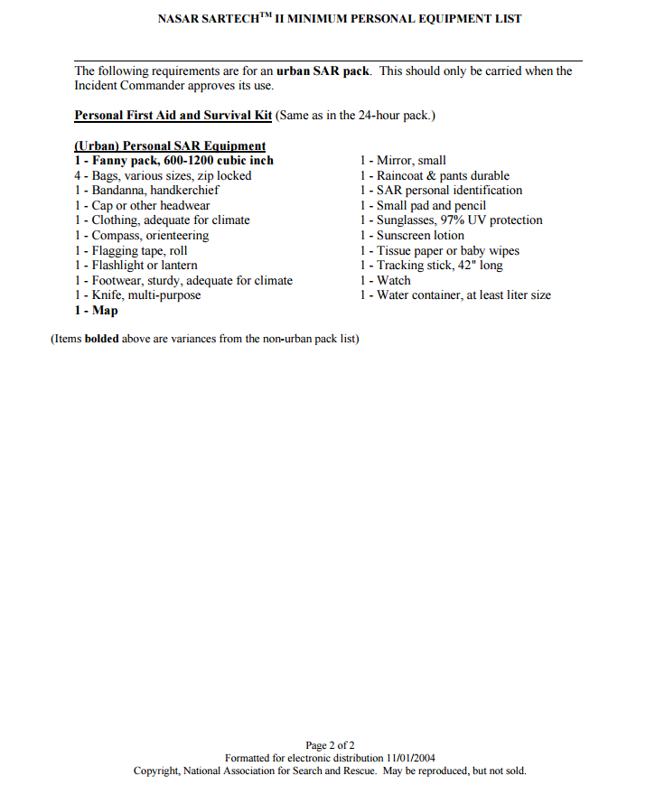
In addition to the items listed above, Team members must possess a waterproof, Garmin Basecamp compatible GPS (the Garmin GPSMap 64st is recommended) and an Amateur Radio handheld transciever, preferably with APRS built in (the Yaesu FT2DR is recommended).

Appendix 3: Personal Responsibility Statement and Organizational Liability Waiver

